**Basics of c++ :**

What is C++

C++ is a general purpose, case-sensitive, free-form programming language that supports object-oriented, procedural and generic programming.

C++ is a middle-level language, as it encapsulates both high and low level language features.

Object-Oriented Programming (OOPs)

C++ supports the object-oriented programming, the four major pillar of object-oriented programming ([OOPs](https://www.javatpoint.com/cpp-oops-concepts)) used in C++ are:

1. Inheritance
2. Polymorphism
3. Encapsulation
4. Abstraction

C++ Standard Libraries

Standard C++ programming is divided into three important parts:

* The core library includes the data types, variables and literals, etc.
* The standard library includes the set of functions manipulating strings, files, etc.
* The Standard Template Library (STL) includes the set of methods manipulating a data structure.

Usage of C++

By the help of C++ programming language, we can develop different types of secured and robust applications:

* Window application
* Client-Server application
* Device drivers
* Embedded firmware etc

C++ Program

File: main.cpp

#include <iostream>

**using** **namespace** std;

**int** main() {

   cout << "Hello C++ Programming";

**return** 0;

}

**Difference between C and C++**

What is C?

C is a structural or procedural oriented programming language which is machine-independent and extensively used in various applications.

C is the basic programming language that can be used to develop from the operating systems (like Windows) to complex programs like Oracle database, Git, Python interpreter, and many more. C programming language can be called a god's programming language as it forms the base for other programming languages. If we know the C language, then we can easily learn other programming languages. C language was developed by the great computer scientist Dennis Ritchie at the Bell Laboratories. It contains some additional features that make it unique from other programming languages.

What is C++?

C++ is a special-purpose programming language developed by **Bjarne Stroustrup** at Bell Labs circa 1980. C++ language is very similar to C language, and it is so compatible with C that it can run 99% of C programs without changing any source of code though C++ is an object-oriented programming language, so it is safer and well-structured programming language than C.

**Let's understand the differences between C and C++.**

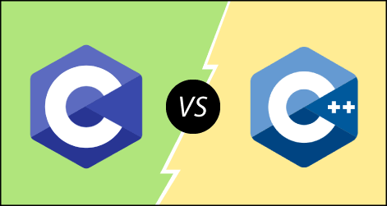

**The following are the differences between C and C++:**

* **Definition**  
  C is a structural programming language, and it does not support classes and objects, while C++ is an object-oriented programming language that supports the concept of classes and objects.
* **Type of programming language**  
  C supports the structural programming language where the code is checked line by line, while C++ is an object-oriented programming language that supports the concept of classes and objects.
* **Developer of the language**  
  Dennis Ritchie developed C language at Bell Laboratories while Bjarne Stroustrup developed the C++ language at Bell Labs circa 1980.
* **Subset**  
  C++ is a superset of C programming language. C++ can run 99% of C code but C language cannot run C++ code.
* **Type of approach**  
  C follows the top-down approach, while C++ follows the bottom-up approach. The top-down approach breaks the main modules into tasks; these tasks are broken into sub-tasks, and so on. The bottom-down approach develops the lower level modules first and then the next level modules.
* **Security**  
  In C, the data can be easily manipulated by the outsiders as it does not support the encapsulation and information hiding while C++ is a very secure language, i.e., no outsiders can manipulate its data as it supports both encapsulation and data hiding. In C language, functions and data are the free entities, and in C++ language, all the functions and data are encapsulated in the form of objects.
* **Function Overloading**  
  Function overloading is a feature that allows you to have more than one function with the same name but varies in the parameters. C does not support the function overloading, while C++ supports the function overloading.
* **Function Overriding**  
  Function overriding is a feature that provides the specific implementation to the function, which is already defined in the base class. C does not support the function overriding, while C++ supports the function overriding.
* **Reference variables**  
  C does not support the reference variables, while C++ supports the reference variables.
* **Keywords**  
  C contains 32 keywords, and C++ supports 52 keywords.
* **Namespace feature**  
  A namespace is a feature that groups the entities like classes, objects, and functions under some specific name. C does not contain the namespace feature, while C++ supports the namespace feature that avoids the name collisions.
* **Exception handling**  
  C does not provide direct support to the exception handling; it needs to use functions that support exception handling. C++ provides direct support to exception handling by using a try-catch block.
* **Input/Output functions**  
  In C, scanf and printf functions are used for input and output operations, respectively, while in C++, cin and cout are used for input and output operations, respectively.
* **Memory allocation and de-allocation**  
  C supports calloc() and malloc() functions for the memory allocation, and free() function for the memory de-allocation. C++ supports a new operator for the memory allocation and delete operator for the memory de-allocation.
* **Inheritance**  
  Inheritance is a feature that allows the child class to reuse the properties of the parent class. C language does not support the inheritance while C++ supports the inheritance.
* **Header file**  
  C program uses **<stdio.h>** header file while C++ program uses **<iostream.h>** header file.

**Let's summarize the above differences in a tabular form.**

|  |  |  |
| --- | --- | --- |
| **No.** | **C** | **C++** |
| 1) | C follows the **procedural style programming.** | C++ is multi-paradigm. It supports both **procedural and object oriented.** |
| 2) | Data is less secured in C. | In C++, you can use modifiers for class members to make it inaccessible for outside users. |
| 3) | C follows the **top-down approach.** | C++ follows the **bottom-up approach.** |
| 4) | C does not support function overloading. | C++ supports function overloading. |
| 5) | In C, you can't use functions in structure. | In C++, you can use functions in structure. |
| 6) | C does not support reference variables. | C++ supports reference variables. |
| 7) | In C, **scanf() and printf()** are mainly used for input/output. | C++ mainly uses stream **cin and cout** to perform input and output operations. |
| 8) | Operator overloading is not possible in C. | Operator overloading is possible in C++. |
| 9) | C programs are divided into **procedures and modules** | C++ programs are divided into **functions and classes.** |
| 10) | C does not provide the feature of namespace. | C++ supports the feature of namespace. |
| 11) | Exception handling is not easy in C. It has to perform using other functions. | C++ provides exception handling using Try and Catch block. |
| 12) | C does not support the inheritance. | C++ supports inheritance. |

**C++ history**

**History of C++ language** is interesting to know. Here we are going to discuss brief history of C++ language.

**C++ programming language** was developed in 1980 by Bjarne Stroustrup at bell laboratories of AT&T (American Telephone & Telegraph), located in U.S.A.

**Bjarne Stroustrup** is known as the **founder of C++ language.**



It was develop for adding a feature of **OOP (Object Oriented Programming)** in C without significantly changing the C component.

C++ programming is "relative" (called a superset) of C, it means any valid C program is also a valid C++ program.

Let's see the programming languages that were developed before C++ language.

|  |  |  |
| --- | --- | --- |
| **Language** | **Year** | **Developed By** |
| Algol | 1960 | International Group |
| BCPL | 1967 | Martin Richard |
| B | 1970 | Ken Thompson |
| Traditional C | 1972 | Dennis Ritchie |
| K & R C | 1978 | Kernighan & Dennis Ritchie |
| C++ | 1980 | Bjarne Stroustrup |

**C++ Features**

C++ is a widely used programming language.

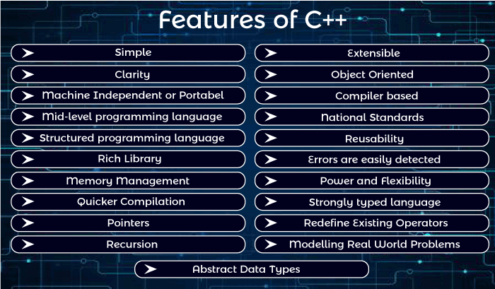

It provides a lot of features that are given below.

1. Simple
2. Abstract Data types
3. Machine Independent or Portable
4. Mid-level programming language
5. Structured programming language
6. Rich Library
7. Memory Management
8. Quicker Compilation
9. Pointers
10. Recursion
11. Extensible
12. Object-Oriented
13. Compiler based
14. Reusability
15. National Standards
16. Errors are easily detected
17. Power and Flexibility
18. Strongly typed language
19. Redefine Existing Operators
20. Modeling Real-World Problems
21. Clarity

1) Simple

C++ is a simple language because it provides a structured approach (to break the problem into parts), a rich set of library functions, data types, etc.

2) Abstract Data types

In C++, complex data types called Abstract Data Types (ADT) can be created using classes.

3) Portable

C++ is a portable language and programs made in it can be run on different machines.

4) Mid-level / Intermediate programming language

C++ includes both low-level programming and high-level language so it is known as a mid-level and intermediate programming language. It is used to develop system applications such as kernel, driver, etc.

5) Structured programming language

C++ is a structured programming language. In this we can divide the program into several parts using functions.

6) Rich Library

C++ provides a lot of inbuilt functions that make the development fast. Following are the libraries used in C++ programming are:

* <iostream>
* <cmath>
* <cstdlib>
* <fstream>

7) Memory Management

C++ provides very efficient management techniques. The various memory management operators help save the memory and improve the program's efficiency. These operators allocate and deallocate memory at run time. Some common memory management operators available C++ are new, delete etc.

8) Quicker Compilation

C++ programs tend to be compact and run quickly. Hence the compilation and execution time of the C++ language is fast.

Advertisement

9) Pointer

C++ provides the feature of pointers. We can use pointers for memory, structures, functions, array, etc. We can directly interact with the memory by using the pointers.

10) Recursion

In C++, we can call the function within the function. It provides code reusability for every function.

11) Extensible

C++ programs can easily be extended as it is very easy to add new features into the existing program.

12) Object-Oriented

In C++, object-oriented concepts like data hiding, encapsulation, and data abstraction can easily be implemented using keyword class, private, public, and protected access specifiers. Object-oriented makes development and maintenance easier.

13) Compiler based

C++ is a compiler-based programming language, which means no C++ program can be executed without compilation. C++ compiler is easily available, and it requires very little space for storage. First, we need to compile our program using a compiler, and then we can execute our program.

14) Reusability

With the use of inheritance of functions programs written in C++ can be reused in any other program of C++. You can save program parts into library files and invoke them in your next programming projects simply by including the library files. New programs can be developed in lesser time as the existing code can be reused. It is also possible to define several functions with same name that perform different task. For Example: abs () is used to calculate the absolute value of integer, float and long integer.

15) National Standards

C++ has national standards such as ANSI.

16) Errors are easily detected

It is easier to maintain a C++ programs as errors can be easily located and rectified. It also provides a feature called exception handling to support error handling in your program.

17) Power and Flexibility

C++ is a powerful and flexible language because of most of the powerful flexible and modern UNIX operating system is written in C++. Many compilers and interpreters for other languages such as FORTRAN, PERL, Python, PASCAL, BASIC, LISP, etc., have been written in C++. C++ programs have been used for solving physics and engineering problems and even for animated special effects for movies.

18) Strongly typed language

The list of arguments of every function call is typed checked during compilation. If there is a type mismatch between actual and formal arguments, implicit conversion is applied if possible. A compile-time occurs if an implicit conversion is not possible or if the number of arguments is incorrect.

Advertisement

19) Redefine Existing Operators

C++ allows the programmer to redefine the meaning of existing operators such as +, -. **For Example,** The "+" operator can be used for adding two numbers and concatenating two strings.

20) Modelling real-world problems

The programs written in C++ are well suited for real-world modeling problems as close as possible to the user perspective.

21) Clarity

The keywords and library functions used in C++ resemble common English words.

**Turbo C++ - Download & Installation**

There are many compilers available for C++. You need to download any one. Here, we are going to use **Turbo C++**. It will work for both C and C++. To install the Turbo C++ software, you need to follow following steps.

1. Download Turbo C++
2. Create turboc directory inside c drive and extract the tc3.zip inside c:\turboc
3. Double click on install.exe file
4. Click on the tc application file located inside c:\TC\BIN to write the c program

1) Download Turbo C++ software

You can download turbo C++ from many sites. [**download Turbo c++**](https://www.javatpoint.com/cpp/software/tc3.zip)

2) Create turboc directory in c drive and extract the tc3.zip

Now, you need to create a new directory turboc inside the c: drive. Now extract the tc3.zip file in c:\turboc directory.

3) Double click on the install.exe file and follow steps

Now, click on the install icon located inside the c:\turboc

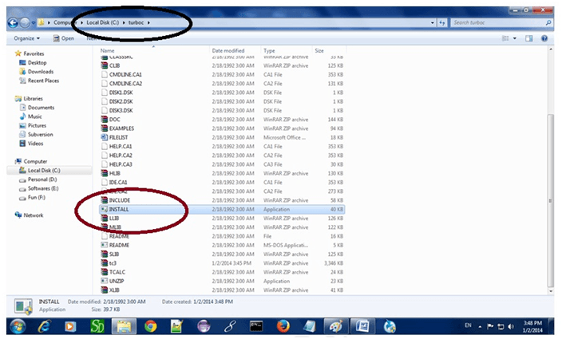

It will ask you to install c or not, press enter to install.

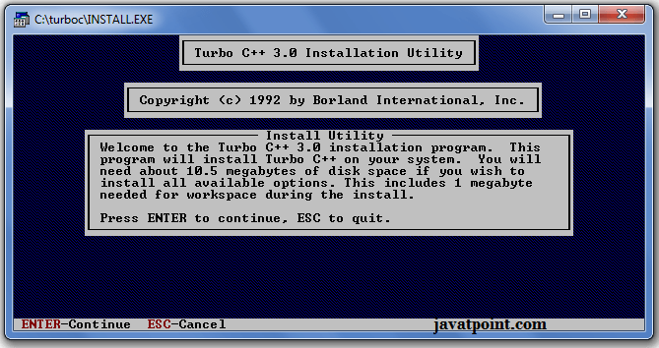

Change your drive to c, press c.

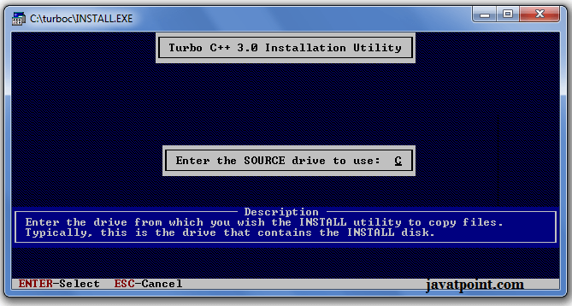

Press enter, it will look inside the c:\turboc directory for the required files.

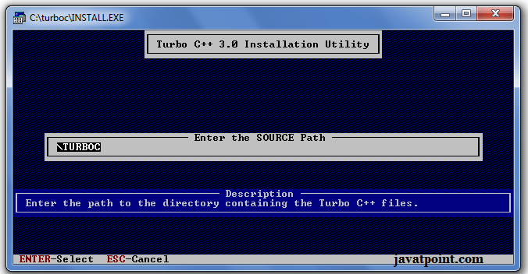

Select Start installation by the down arrow key then press enter.

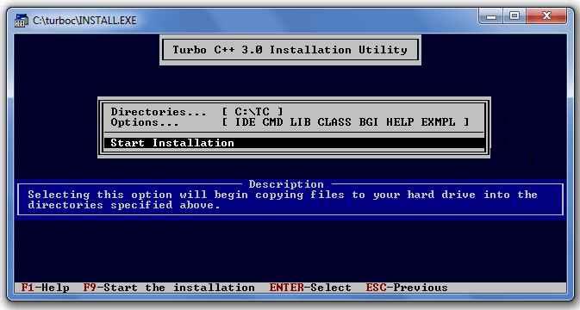

Now C is installed, press enter to read documentation or close the software.

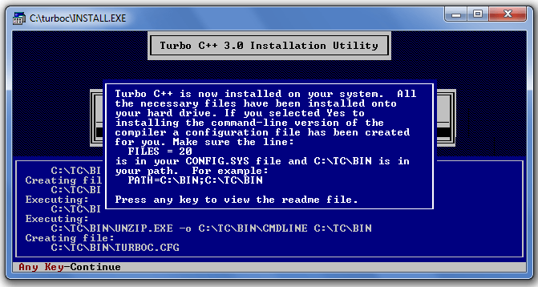

4) Click on the tc application located inside c:\TC\BIN

Now double click on the tc icon located in c:\TC\BIN directory to write the c program.

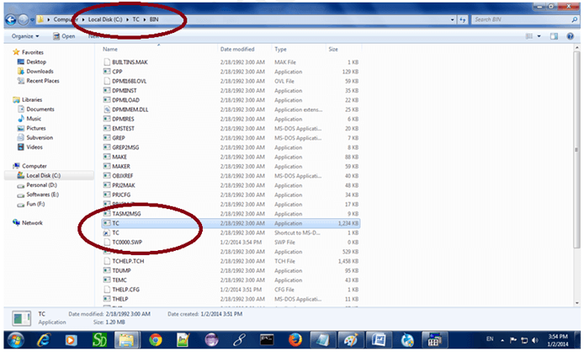

In windows 7 or window 8, it will show a dialog block to ignore and close the application because full screen mode is not supported. Click on Ignore button.

Now it will showing following console.

